***REMIND: Join our Group***

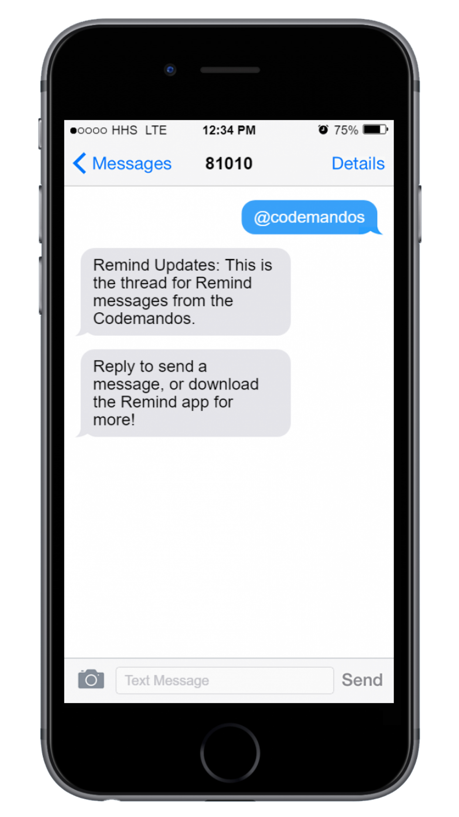Text **@codemandos** to **81010**